Chapter 4

RAMP-TRIM Users Manual

Box/Container and
Shipment/Transfer Module

United Nations Children’s Fund
3 United Nations Plaza
New York, New York 10017

Chapter 4. Boxes and Shipment

Table of Contents

4.1 Introduction to Boxes (Container) 4
4.1.1 What is a Box (Container)? 4
4.1.2 What are the Determining Features of a Box (Container)? 4
4.1.3 How to start a Box (Container)? 4
4.1.4 Additional Information on Boxes 4
4.1.5 Deleting Boxes 5
4.2 Introduction to Transfer/Shipment 5
4.2.1 What is a Transfer/Shipment? 5
4.2.2 Determining information needed for a Transfer/Shipment 5
4.2.3 Additional Information on Transfer/Shipment 6
4.3 Procedures - Boxes 6
4.3.1 Creating the Box Records 6
4.3.2 Adding Several Box Records at Once (Copy Function) 8
4.3.3 Attaching Folders to Boxes 9
4.3.4 Box Reports 9
4.4 Procedures - Transfer (called 'Shipment-Box-Group' in TRIM) 10
4.4.1 Creating the Transfer Record [DRW and RAMP – For Trim Administrator Only] 10
4.4.2 Listing Boxes and Transfers 12
4.4.3 Adding Boxes to a Transfer/Shipment 12
4.5 Modifications – Boxes and Transfers 12
4.5.1 Modifying an Existing Record 12
4.5.1.1 Basic Operations 12
4.5.1.2 Changing Multiple Records 13
4.5.2 Typical Tasks 13
4.5.3 Printing Box Records 14
4.6 Box – Folder Exercises 16
4.7 Transfer/Shipment Exercises [with Assistance from DFAM/DRU and RAMP-TRIM Administrator] 18
4.8 Key Learning Points 19
4.9 Self Test Questions 20
4.9.1 Box/Container Information 20
4.9.2 Using the RAMP_TRIM Database: Review 20
4.9.3 Transfer/Shipment and Box/Container 21

List of Figures

Figure 1. Assignment of the Series – Organize in Folders – Transfer in Boxes 5
Figure 2. New Box Record Entry Form 6
Figure 4. Standard RAMP-TRIM Report 10
Figure 5. Shipment-Box-Group Entry Form 11
Figure 6. Selecting Report Options 14
Figure 7. Standard RAMP-TRIM Report 15

Boxes and Shipments

Introduction to Boxes (Container)

What is a Box (Container)?
A Box is a receptacle in which records are stored. Since many of the storage facilities do not have temperature-controlled environments, these containers must be quite sturdy. They are usually made of heavy-duty cardboard. Since they must hold quite a few file boxes, they are also sufficiently large to accommodate up to 35 pounds of manila file folders.

Some terms employed in the RAMP-TRIM system take into account different usage at UNICEF and the UN. For example, although record movement is called Transfer at UNICEF, the term used at the UN is Shipment; although called a Box at UNICEF, the term Container is used at the UN.

What are the Determining Features of a Box (Container)?
The most important thing to remember about the storage box is its function: it must hold and protect records for many years. Boxes come with assembly instructions that must be followed carefully. Particularly important is the double layering that should be the result of careful folding and assembly of the boxes. Be sure the bottom is secure! It has happened several times, in the middle of transit, that the bottom of a box has fallen out and the contents have become soiled and mixed-up.

How to start a Box (Container)?
Using RAMP-TRIM, find the Box Record Type (see description earlier) to Add a box. Certain data must be entered on this screen: External reference/Local box number field using the Division/Section prefix, a title/description, earliest & latest date of the records, and the box sequence:
e.g. Ext.Ref: Local Box Number: RURR/ADM/1999-T003,
Title/Description: Correspondence, Copenhagen-Hanoi,
Earliest Date 01/Jan/1992-
Latest Date: 12 Dec/97,
Box Sequence: #2 (02 of 03).

Additional Information on Boxes
Once individual box(es) are set up the folders can be selected to be included in the box (es). The actual physical preparation normally precedes the creation of the electronic records. The creation of the electronic description of the box may proceed in parallel with the preparation of the box records.

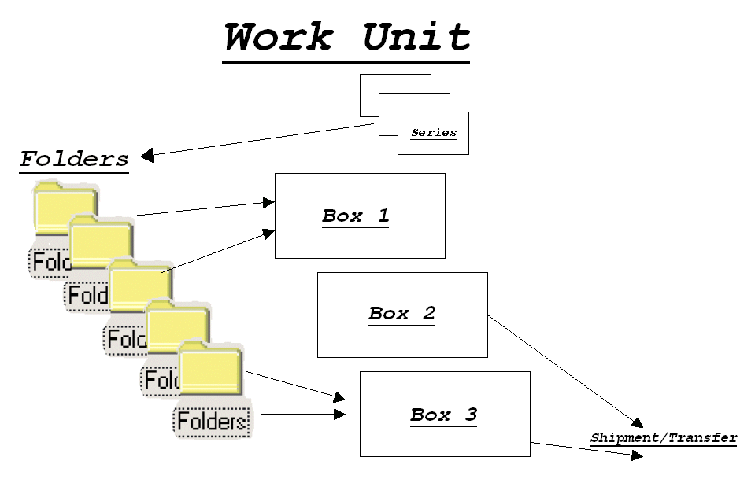
Figure 1. Assignment of the Series – Organize in Folders – Transfer in Boxes

Deleting Boxes
If for some reason the work unit wants to delete or modify a transfer, they should contact DRU who will coordinate with the RAMP-TRIM system administrator.

Introduction to Transfer/Shipment

What is a Transfer/Shipment?
A transfer is the removal of records from one location, the shipment and the deposition of them to another area for storage. Some of the circumstances that might initiate a transfer are: not enough space (usually for records over 3 years old), reclassification of records, or the moving of an office/work unit (often to another floor or building). There are actually two transfers: one made electronically in the RAMP-TRIM system, and the other the actual, physical transfer of records. The electronic transfer normally precedes the physical transfer of records.

Determining information needed for a Transfer/Shipment
In order for a transfer to be made, certain data must first be entered into the RAMP-TRIM system. The most important data are: The year and the assigned number of the transfer, the title/description, the estimated dates of the material, projected years in storage, the room number where the records are to be picked up from, where the records are to be moved to, the estimated number of boxes, how frequently the records are used (will be used), who is preparing the transfer/shipment, and who is responsible (the office supervisor).

Additional Information on Transfer/Shipment
The completion of the information of the transfer/shipment description is a joint responsibility of the Division/Section sending the records and the DFAM/DRU. The RAMP-TRIM administrator monitors and assists the process. The Unicef RAM officer confirms the Unicef and/or UN accession number for the shipment.

Procedures - Boxes

Creating the Box Records
Before assembling file folders for transfer the box records must be created. To do this, go to the Menu bar navigate to the File, New Record (Ctrl-N), select The Box record type and select Ok to display the Box entry form. You are now asked to enter information describing the box record into select fields that are describe here. Some fields are required [R], have default values [D], are optional [O] or have a combination of both. The Box Record entry form is displayed below.

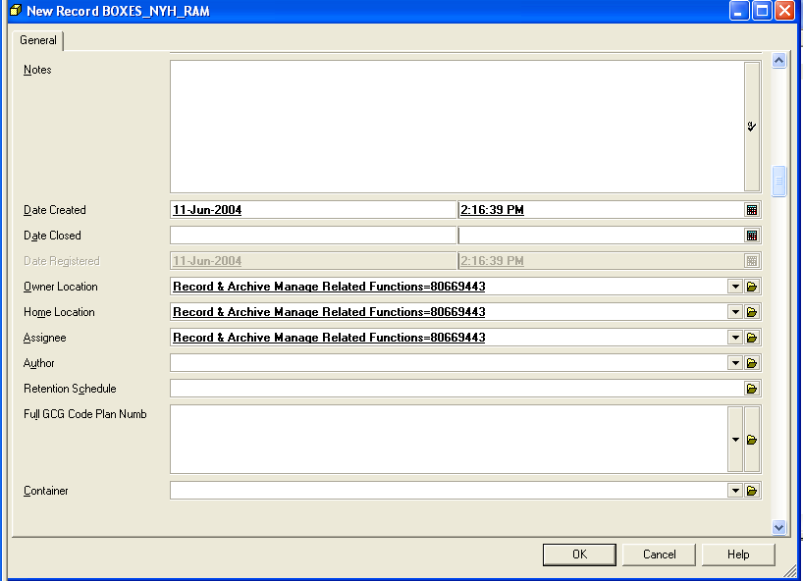

Figure 2. New Box Record Entry Form

Record Box Title [R]: The title (alpha-numeric) applied to the folder helps in identification of folder. This is a required field.

Series Record [R]: Select an appropriate series record that the box will be related to. This is a required field.

Notes [O]: Descriptive text contributing to the researcher’s understanding of the Box and folders within records.

ExtRef: Local Box Year-Numb [O]: Enter information that will assist you in identifying the box. Begin with the division, section and unit code followed by a short text or number. Remember to keep this entry short and do not repeat information already recorded in the Title field. Work unit prefix and year- number, (and any other information you want to include.) Strongly recommended.

Notes [O]: Descriptive text contributing to the researcher’s understanding of the Box and folders within records.

Date Created [R/D]: The date on which the box was created. The field is populated automatically.

Date Closed [R/D]: The date the box record was closed. The field is populated automatically. This field cannot be dated before the date created.

Date Registered [R/D]: The date the box record was registered. This field is populated automatically.

Owner Location [R/D]: The organisation, unit or individual responsible for the box record. The field value will default to your division, unit or organisation. Use the Kwikselect feature to identify the value in the organisation directory (locations).

Home Location [R/D]: The organisation, unit or individual where the box records normally reside. The field value will default to your division, unit or organization. Use the Kwikselect feature to change the value in the directory (locations) file. Once the box is sent to storage, the home location of the box will change to reflect this status.

Assignee [R/D]: The field value will default to the division, unit or organisation. The field value will default to the division, unit or organization. Use feature to identify the value in the directory (locations) file.

Author [O]: Use the Kwikselect feature to identify the value in directory (locations) file.

Retention Schedule [O]: Apply the retention schedule. Use the KwikSelect to navigate to the retention schedule authority file.

Full GOG Code Plan Number [O]:

Additing Additional User Fields
Once the above fields are completed as necessary, click OK to save. Right click, then go to Details/user Fields
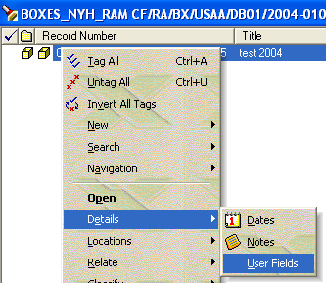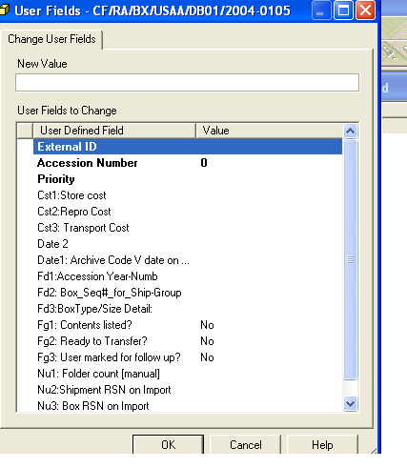

Figure 3. Right Click navigate to Details/User Fields

Nu1: Folder Count (manual) [O]: Total number of folders in the box.

Fd3 Box Type Size Detail [O]: Describe the type of record box.

Fg1 Contents List [O]: Check this box if an inventory list exists.

Fg2 Ready for Transfer [O]: Check this box if the record box is ready for transfer.

Fg3 User Marked for followup[O]: Check this box if followup is required.

Fd1 Accession Year-Number [Only for System Administrator]: Accession year-number. Enter the full year of accession, e.g. 1998, or number, e.g. 98-100. This field will be added by DFAM/DRU and confirmed with RAMP-TRIM system administrator for all boxes when a specific shipment is processed. When shipments are identified for possible storage at the UN archives, a temporary accession number may be assigned and later revised to conform to UN assigned accession number.

Fd2 Box Seq# for Shipment [R]: This is the box number in the shipping sequence. For example, box number 3 or 12 boxes in the shipment.

Click OK to save. The Box record is automatically numbered, although you will be given a prompt to confirm record numbering. Select Ok to create the record, or Cancel to return to the record entry form.

Note: It is possible for a user to create a box record with a higher security level than they have access to, however they will not be able to view the record after its creation. Check with RAMP-TRIM System Administrator if you have this problem.

Adding Several Box Records at Once (Copy Function)
If you are entering box records into the RAMP-TRIM application for the first time or rearranging records, it may be desirable to enter several similar records at once. This is done through the copy function which makes it unnecessary to re-enter common information.

First, create a box record or perform a search for the box to be copied (see Section 2 or 3 for more information on searching). Tag or highlight the desired record and now navigate to the Menu selection File and Copy Record.

In the copy screen, select the fields (characteristics) to copy. Generally copy all fields unless it is necessary to change the field values. Enter the number of copies to be generated and select Ok. Exact copies of the records will be produced. The records will be created and given unique record numbers. It is now necessary to annotate the copy(ies) to make it a unique record. Often this is done by changing the title information.

Attaching Folders to Boxes
Once the Box record(s) is created you are ready to place Folders into the box. Conduct a search for the desired folders. Use search criteria that return the desired record. For example, a date range or a department name in a complex search. Select the desired records using the tag-and-task.

Right click and Navigate to Container. You are asked, “Apply to: 1) all tagged rows, or 2) currently highlighted row?” Make the appropriate selection and select Ok.

Be sure the radio button “Enclose the Record Now” is checked. Use the drop-down box to select recently used containers, or the Kwikselect to search for a box (container) record. Select Ok and the Folders are contained in the Box.

You can verify this through the Navigation menu option and toggling between Contained Within and Container reports.

Box Reports

You may wish to print a Box record or a list of Box records. Use the following procedures to print reports. Conduct a search as described previously.

Select a Box by highlighting, or select several boxes using the tag-and-task function. Navigate to the Menu selection File (Alt.F), Print Report ( Ctrl-R), select the report titled CF_BOX or CF-BOX_Folders. Enter the Optional Title to customize the report title and Select Preview and/or Print Report.

The reports found in the RAMP-TRIM, File, Print Report are standard reports. Reports can also be customized for unique needs. Consult with the RAMP-TRIM Systems Administrator for information concerning customization of reports.

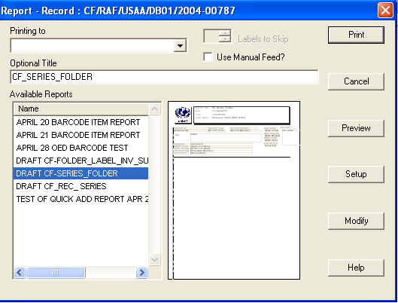

Figure 3. Standard RAMP-TRIM Report

Procedures - Transfer (called 'Shipment-Box-Group' in TRIM)
When you are ready to transfe or ship your boxes, send an e-mail message giving basic information on the boxes and a title for a Transfer/Shipment form and discuss with RAMP-TRIM Administrator .

Creating the Transfer Record [DRW and RAMP – For Trim Administrator Only]
Create the transfer records by completing the New 'Shipment-Box-Group' transfer record
form. The form contains the following fields. Some fields are required [R], have default values [D], are optional [O] or have a combination of both.

Transfer/Shipment-Box-Group Title [R]: Enter a title that identifies the shipment.

Notes [O]: Descriptive text contributing to the researcher’s understanding of the Box and folder records within the shipment records.

Date Created [R/D]: The date on which the shipment was created. The field is populated automatically.

Date Registered [R/D]: The date the box record was registered. This field is populated automatically

Fd1: Archive Code Div/Sec/Unit [R]:

Date Closed [R/D]: The date the last box record within the shipment was closed. The field is populated automatically. This field cannot be dated before the date created.

Fd2: Ship Date Range [of contents] [R]: Identify the full date range of records in the shipment.

Fd3: Ship Destination Bldg., Shelf Range [R]:

Owner Location [R/D]: The organisation, unit or individual responsible for the shipment record. The field value will default to your division, unit or organisation. Use the Kwikselect feature to identify the value in the organisation directory (locations).

Author [O]: Use the Kwikselect feature to identify the value in the directory (locations) file [primary contact]. Use KwikSelect to list all “other” contacts.

Assignee [R/D]: Use this field to identify the value in the directory (locations) file.

Security Level [O]: Enter the security level from the drop down box.

Retention Schedule [R]: Apply the retention schedule. Use the KwikSelect to navigate to the retention schedule authority file [under review].

Date2: Date Ship Rev [R]: Date of the shipment.

Nu1: Estimated Count of Boxes [R]: Estimated number of boxes in the shipment.

Flg2: Shipment Requires Special Protection [O]: Use the radio button to indicate special protection.
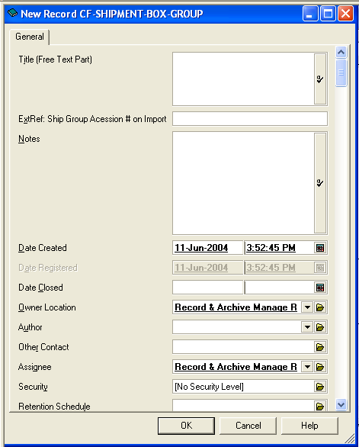
Figure 4. Shipment-Box-Group Entry Form

Listing Boxes and Transfers

You will build boxes into a shipment for transfer off site to the records center. In RAMP-TRIM this is called the shipment/transfer.

Adding Boxes to a Transfer/Shipment
Once the Box and Transfer/Shipment-Box-Group records are created you are ready to place Boxes into the Transfer/Shipment/Box-Group. Conduct a search for the desired boxes. Use search criteria that return the desired record. For example, use a date range or a department name in a complex search. Select the desired records using the tag-and-task. There is no limit to the number of boxes that can be applied in a shipment-box-group. If a shipment has more than 50 boxes, discuss with RAMP_Trim Administrator and DFAM/DRU if it might be more practical to transfer in two or more shipments.

Go to the Menu option Tasks then Series to place your boxes into a Shipment-Box-Group. You are asked, “Apply to: 1) all tagged rows, or 2) currently highlighted row?” Make the appropriate selection and select Ok.

Use the drop-down box to select your Shipment-Box-Group, or the KwikSelect to search for a Shipment-Box-Group record. Select Ok and the Boxes are now contained in the Shipment-Box-Group.

You can verify this through the Navigation menu option and toggling between Series Within and Record Series.

Modifications – Boxes and Transfers

Modifying an Existing Record

Basic Operations
It may become necessary to update or modify an existing folder, box or new shipment-box-group record. These records, in fact all RAMP-TRIM records, are modified through Task menu function. Any information field [e.g. title, notes, and extra details] can be modified by an authorized user. Begin by searching and locating the desired record. The procedures are discussed below, for screen illustrations review Chapters 2 and 3 which contain screen illustrations.

Once the record(s) are highlighted, identify the task which you would like to perform and navigate to the designated selection on the Task menu. The most common maintenance tasks include changes to title, container, contact(s), series, extra details, notes and dates.

Active tasks are shown in bold type. Some Tasks may not be available to you due to security authorization. If you require access to tasks that are not present on your screen contact the RAMP-TRIM Administration.

Just prior to seeing some record modification screens you will be asked, “Does this change apply to All Tagged Rows? or The Currently Highlighted Row.” Make the appropriate selection to proceed.

Changing Multiple Records

This procedure is called tag-and-task in RAMP-TRIM. First find the desired records by conducting a search as illustrated in Section 3.2.1, Identifying or Listing Folders. Tag the records by locating the mouse just to the left of the yellow button or series icon. Depress the left mouse button to activate or deactivate the green check mark – this is the selection indicator. Alternately, move the cursor to the right of the Yellow series icon and use the right mouse button to tag or untagged all records in the Record View Pane.

Any task now performed will apply to all tagged records. Refer to the basic operations for more information on Tasks.

Typical Tasks

Modify, Title Go to File/Properties or Right Click/Properties. Go to the General Tab page and modify as appropraite.

Modify – Extra Details Right Click/Details/User Fields

Modify – Notes Modify Right Click/Details/Notes. Edit notes as appropriate.

Enter up to 30,000 text characters. This is a text field and has no word processing functions. Do not attempt to format this field because format settings are not saved. Apply spell check and the use stamp for audit purposes.

Modify - Containers Conduct a record search for a Folder record. Right Click/Locations//Container. Check the box titled “Enclose the Record Now” if the folders are to be immediately placed in a box. Be sure the button titled “Set Container To” is checked. Use the drop-down list to review your most recently used containers, or use the Kwikselect to search for a container.

Modify - Contacts Perform a record search for a Box record. Go to File/Properties or Right Click/Properties/Contacts Tabbed Page. Indicate the contact type author, addressee, representative, or other. Only one type can be selected. Next use the Kwikselect to locate a staff member.

Select a contact from the list and select OK to record the selection. If the correct contact is not present select the New menu option and create a citation. You should have all the pertinent identification information before creating a new contact.

Modify - Series It may be necessary to reassign the record series for a folder or make an initial record series assignment for a folder. Go to File/Properties or Right Click/Properties/General Tabbed Page. On the Series Record field, follow prompts to conduct search.

Open the Kwikselect and a standard search screen will be displayed. Use the Record Type menu option to ensure the search is performed for record series.

Record Series search results are presented in a standard record list and record view panes. Select the OK button to send the selected records Series to the capture form.

Record the Record Series entry by selecting OK.

Note that the Series Record can be assigned and displayed in the Record View Pane.

Modify – Dates Modify Right Click/Details/Dates. Open the date modification window and edit dates as appropriate. Just prior to seeing the Record modification screen you will be asked, does this change apply to All Tagged Rows or the Currently Highlighted Row. Make the appropriate selection.

Change a date by using the mouse to check the active box and changing the date. Inactive date fields are underlit.

Printing Box Records

You may wish to print a Box record or a list of Box records. These reports, and many others, may be used by members of the organization. Use the following procedures to print reports.

Conduct a search.

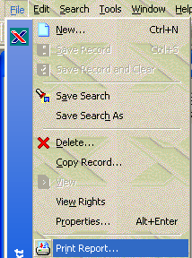

Figure 5. Selecting Report Options

The reports found in the RAMP-TRIM, File, Print Report are standard reports. Reports can also be customized for unique needs. Consult with the RAMP-TRIM Systems Administrator for information concerning customization of reports.

Figure 6. Standard RAMP-TRIM Report

Similar reports are available if you are reviewing the shipment:
- CF_Ship
or - CF_Ship_Box

Box – Folder Exercises

1. Add Box 1993-T001 [your logon id]
Correspondence, Abidjan – Conacry [your name]

2. Modify one Box

Change: 1993-T001 [ID]
Correspondence; Abidjan –conacry [your name]
To: 1990-T001[ID]
Correspondence; Abidjan – Copenhagen [your name]"

3. Add Two more Boxes [Copy Record]

1993-T001 [ID] Correspondence; Harare – Lima [ID]
1993-T001 [ID] Correspondence; Lisbon to Windhoek [ID]

4. Modify Boxes [TAG and TASK]

Change: Correspondence" to "Communication" on title.
For Example:

1993-T001[ID] Correspondence; Harare - Lima
1993-T001[ID] Correspondence; Lisbon to Windhoek

To: 1993-T001 [ID] Communication; Harare - Lima
1993-T001 [ID] Communication; Lisbon to Windhoek

5. Pick folders for Box "Communication; Harare - Lima"

a) Search for Series

1991-01 Communication with Field office

b) Navigate to Folders within Series

Series_Folder List

X AD-521/CF-ZIMA Correspondence Log Harare
X AD-521/CF-IDSA Correspondence Log Jakarta
X AD-321/CF-IDSA Telex Log Jakarta

c) Select folders to be contained in Box.

d) Navigate To Box and confirm Folders within box.

Transfer/Shipment Exercises [with Assistance from DFAM/DRU and RAMP-TRIM Administrator]

You have been assigned to TEST Work Unit__in Test Section; in Test Division; in Ruratania Sub Office = RURS 8-Using RAMP, find the work unit and go to list of Shipment-Box-Group for that owner location.

1. Find a Transfer/Shipment-Box-Group and fill in the following

Shipment-Box-Group/Transfer Title/Description:
1987 Correspondence Files
Fd2: Shipment Date range [Estimated Dates of Material]: 1987 -1988
Fd3: Shipment Destination Building: LIRC

Nu1: Estimated Number of boxes: 4
Owner Location:.
Author [prepared By]:
Press 3) Go to Next Screen. The following information is optional:

2. List Boxes and Add Boxes to the Shipment-Box-Group

Year/Number Title/Description

1. 1993-T001 Correspondence; Abidjan - Conacry
2. Early Date: 01/01/87 Latest Date: 12/31/87
3. Box Sequence: 1

1. 1993-T002 Correspondence; Copenhagen - Florence
2. Early Date: 01/01/87 Latest Date: 12/31/87
3. Box Sequence: 2

Key Learning Points

Chapter 1 | Organization –Work Unit  Owner Location
Chapter 2 | Find/List Record Series
Chapter 3 | Select Series  Find or Navigate to Folders
Chapter 4 | Select Folders  Task [Assign] Folders to Box [Container]
Find/List boxes
Select Boxes
Task [Assign] Boxes to Shipment-Box-Group [Transfer]

Self Test Questions

Box/Container Information

1. What information must be filled out for each Box?
a)
b)
c)

2. What do you do if you are not sure what to title the box?

3. Do you start a new box for each folder?

4. How do you pick (select) Folders from a series to be included in a box?

5. What do you do if you want to delete or consider a box for disposal?

6 Is it difficult to change a box title or extra details like the External Reference/Local box number?

7. If a group of boxes would be better identified under a different Shipment-Box-Group/Transfer or Work Unit must the data be re-entered?

8. What are the advantages of having a box "title" (summary of contents) and box "contents" (lists of Folders) in each box?

9. Where does one obtain boxes to transfer records?

What is the most important thing to remember when you are assembling a Box?

How many folders will go into a box?

Using the RAMP_TRIM Database: Review

Overview:

Review Series
- Review File folders in a Series

Boxes/Containers:
- Add a Box to a Transfer/Shipment-Group-Box
- Modify a Box
- Move a Folder into a Box
- Print a List of Boxes
- Print a list of Folders in each Box

Finalizing a Transfer/Shipment
- Request Boxes to Assemble
- Assemble boxes
- Print Box Description label of each box and Place on both ends of Box
- When Box listing complete, request space assignment For Boxes with DRU
- Place space assignment labels on Each Box [both ends]
- Notify DRAM/DRU shipment ready for Transfer to storage location

Transfer/Shipment and Box/Container

1. What information must be filled in for Transfer?

2. What conditions or circumstances might initiate a Transfer?

3. What do you do if you are not sure what to title the Transfer?

4. What do you do if you want to delete or modify a Transfer?

5. How do you begin to add boxes to a Transfer?
Questions and Answers

Box/Container information

1. Q: What information must be filled out for each Box?
A a) Local Box number: External Reference
[Location Division/Work Unit Prefix] Year - Number
b) Title/Description
c) Estimated Dates of Material

2. Q: What do you do if you are not sure what to title the box?
A: Enter a vague/Temporary Title based on
a) Estimated Dates of material
b) or Possible Contents

3. Q: Do you start a new box for each folder?
A: No

4. Q: How do you pick (select) folders from a series to be included in a box?
A: Locate Related Record Series; navigate to Folders; Task folder to Container – Box

5. Q: What do you do if you want to delete or consider a box for disposal?
A: Contact RAMP-TRIM System Administrator

6. Q: Is it difficult to change a box title or extra details
such as the external reference: Local Box number?
A: No. Select Box, Right Click, Properties, go to Ext Ref field

7. Q: If a group of boxes would be better identified under a
differentShipment-Box-Group/Transfer or Work Unit must the data be
re-entered?
A: No. Contact RAMP-TRIM system Administrator or DRU for assistance.

8. Q: What are the advantages of having a box "title" (summary of contents) and
box "contents" (lists of boxes) in each box?
A: To assist in Retrieval.
To be certain the folders are put in the right box and put back after retrieved.

9. Q: Where does one obtain boxes to transfer records?
A: DFAM/ Administrative Services/Headquarters Help desk

10. Q: What is the most important thing to remember when you are assembling a
Box?
A: Follow the Numbers and make sure the bottom is secure.

11. Q: How many folders will go into a box?
A: Not too many. Each box file title should be able to be seen for retrieval.
Box cannot be more than 35 lbs. Also there should not be too few folder in a box or boxes for a transfer. The storage and handling charges are based on number boxes transferred.

Transfer/Shipment-Box-Group Forms information

1. Q: What information must be filled in for Transfer?
A: See Section 4.4
Send an e-mail message giving basic information and discuss with RAMP-TRIM Administrator
- Title/Description
- Contents of box
- Estimated Dates of Material:
- Pick up from Room:
- Estimated Number of boxes:
- Person Responsible:
- Frequency of retrievals:
- Author /Prepared By:

2. Q: What conditions or Circumstances might initiate a Transfer.
A: a) Not enough Space - for records over 3 years old
b) Reclassification of Records
c) Time to retire Active Records
d) Office is moving to another floor/Building

3. Q: What do you do if you are not sure what to title the Transfer?
A: Send an e-mail message to RAMP-TRIM system Administrator and DRU
a) Enter a vague/Temporary Title based on
- Estimated Dates of material and
- or Possible Contents
b) A temporary Shipment title will be assigned
- Can begin adding boxes to this shipment

4. Q: What do you do if you want to delete or modify a Transfer?
A: Contact RAMP-TRIm Administrator or DRU

5. Q: How do you begin to add boxes to a Transfer?
A: Select Boxes, Task, Series, Select Shipment-Box-Group, Confirm.

Using the RAMP Database
For detailed answers refer to appropriate chapter of RAMP-TRIM Manual.
Finalizing a Transfer/Shipment
- For more detailed answers on review of Manual Skills for transfer Contact DRU.
- For more information on finalizing a transfer/shipment, see Annex S of RAMP-TRIM Manual.

Just prior to seeing some record modification screens you will be asked, “Does this change apply to All Tagged Rows? or The Currently Highlighted Row.” Make the appropriate selection to proceed.
Just prior to see the Record modification screen you will be ask, does this change apply to All Tagged Rows or the Currently Highlighted Row. Make the appropriate selection.

